LAB # 6
DEADLOCK IN CONCURRENCY
Lab Task
Create three threads by implementing thread synchronization block through 3 locks. (Hint: Apply un-sequenced lock to analyze deadlock and solve it through provided solution.
CODE:
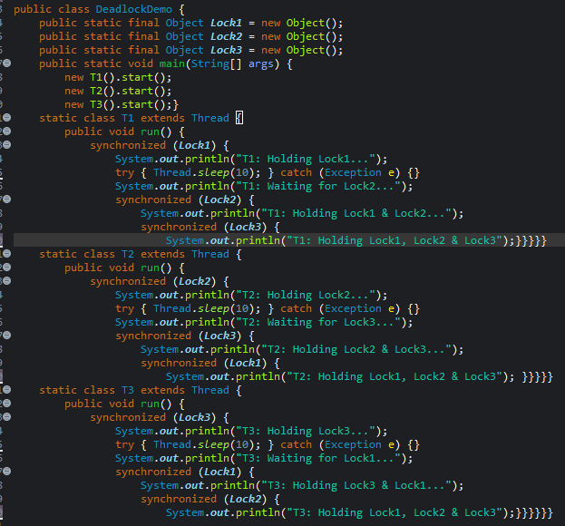

OUTPUT:
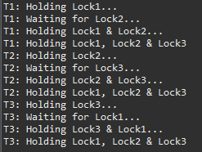

GITHUB SCREENSHOT:

